Module 1: Version Control Basics
A Version Control System (VCS) helps track changes in code over time. It allows multiple developers to collaborate efficiently.
Centralized VCS (like SVN) uses a single server. Distributed VCS (like Git) allows every user to have a full copy of the repository.
Git is preferred because it supports offline work, faster operations, and better collaboration.
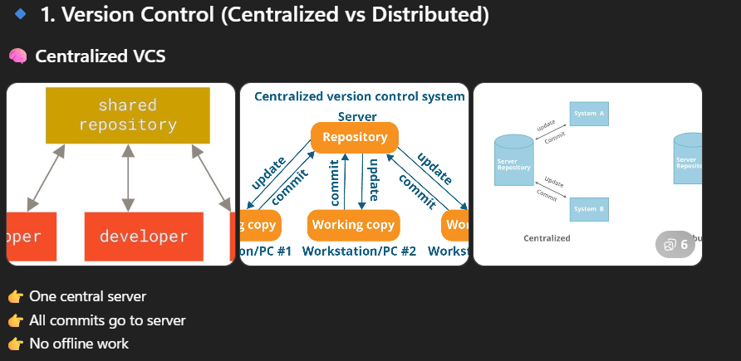
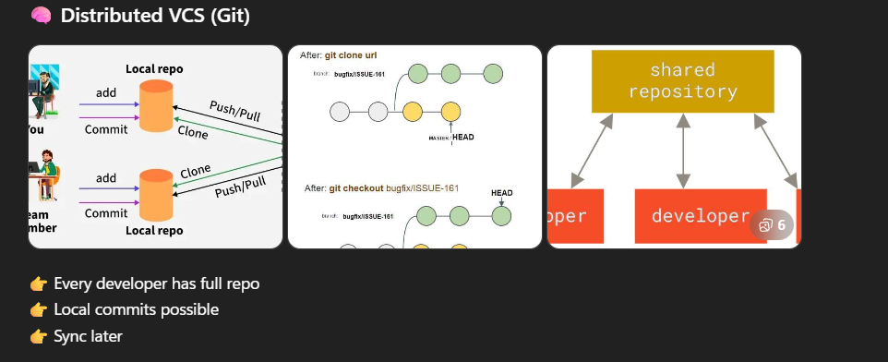
Module 2: Git Basics
Git is a distributed version control system.
git init → Initializes a repository
git status → Shows current changes
git add . → Adds files to staging
git commit -m 'message' → Saves changes with a message
Concept: Git tracks snapshots, not just file changes.
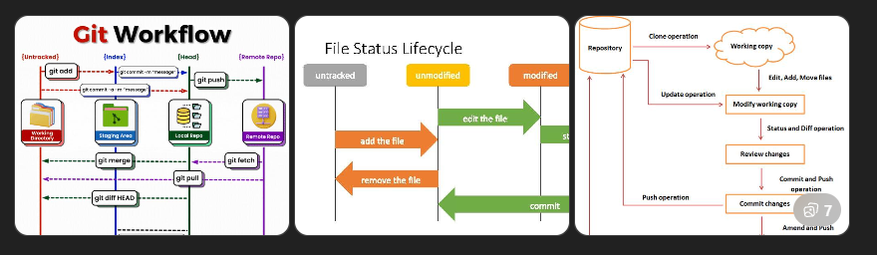
Module 3: Git Architecture
Git works with three main areas:
1. Working Directory – where you edit files
2. Staging Area – where you prepare changes
3. Repository – where commits are stored permanently
Flow: Working Directory → Staging → Commit
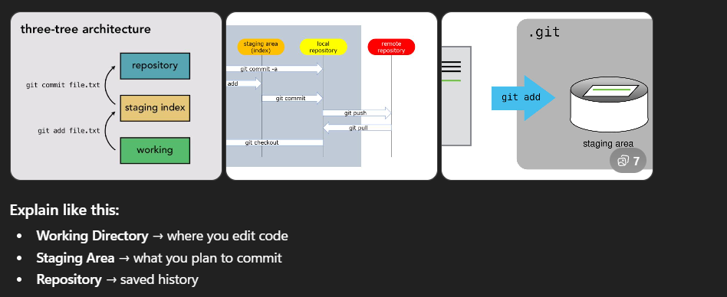
Module 4: Branching & Merging
Branching allows parallel development.
git branch feature → create branch
git checkout feature → switch branch
git merge main → merge changes
Use case: Different developers work on different features without affecting main code.
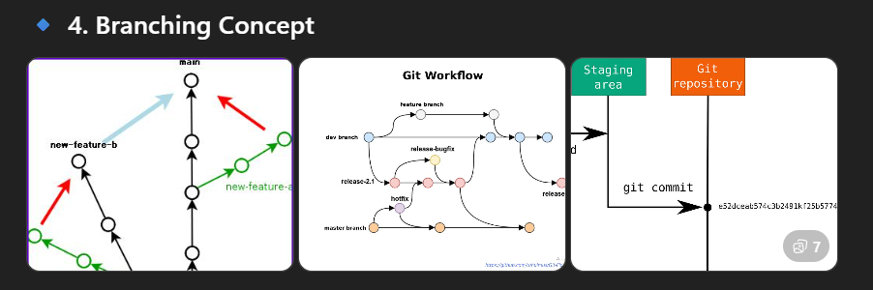
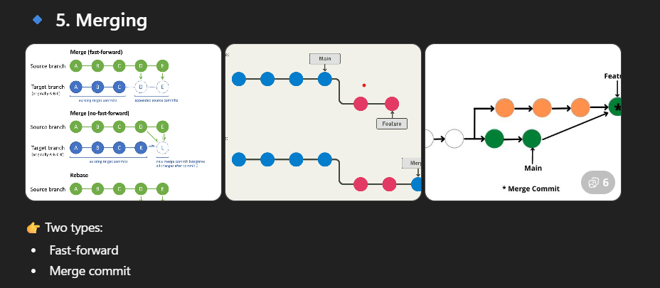
Module 5: Merge Conflicts
Conflicts occur when two people edit the same lines in a file.
Git marks conflicts using:
<<<<<<< HEAD
=======
>>>>>>> branch
Resolution: Manually edit the file, remove markers, and commit.
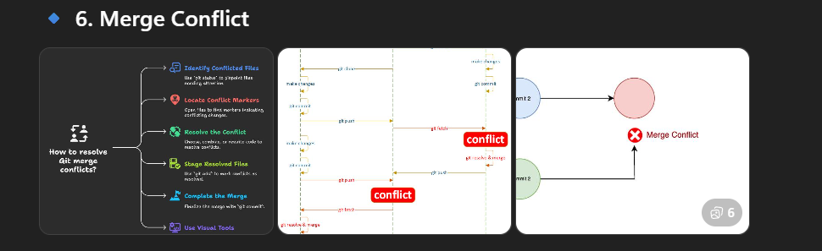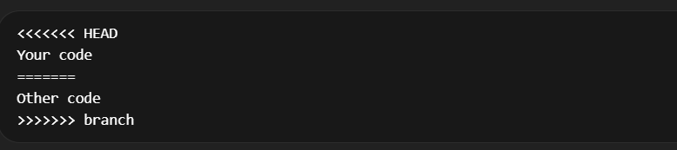
Module 6: GitHub Basics
GitHub is a cloud platform for hosting Git repositories.
git clone → copy repo locally
git push → send changes to GitHub
git pull → get latest changes
It enables collaboration across teams.
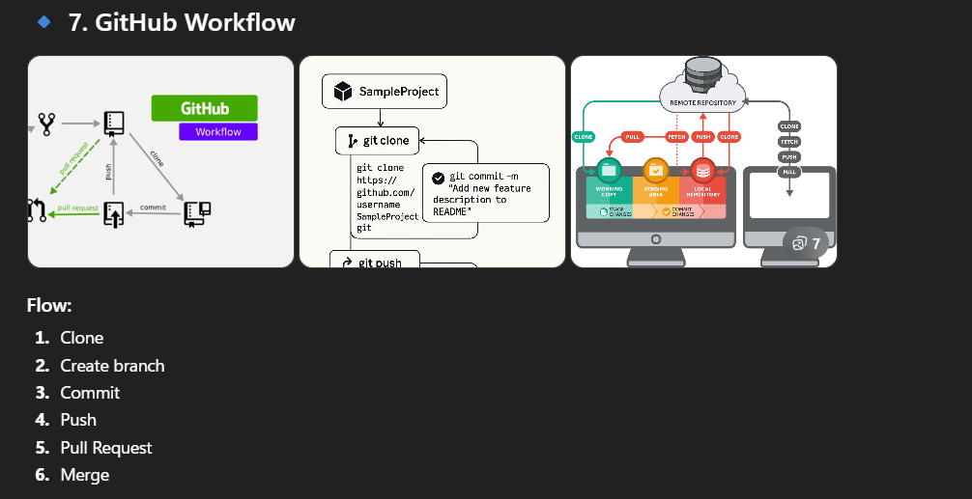
Module 7: Pull Requests
Pull Requests (PR) are used to merge changes with review.
Steps:
1. Push branch
2. Create PR
3. Review code
4. Merge
This ensures code quality and team collaboration.
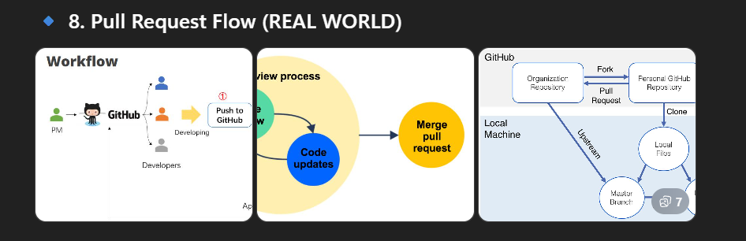
Module 8: Advanced Git
git stash → temporarily save changes
git rebase → rewrite commit history
git reset → remove commits
git revert → undo changes safely
Use these carefully in real projects.
Best Practices
• Commit frequently with meaningful messages
• Always pull before pushing
• Use branches for features
• Avoid committing directly to main branch
• Review code before merging

